Project Plan For
“Time and Attendance System (Hardware and Software)”

Table of Contents

- Section-1: Executive Summary
- Section -2: Scope Management
- Section -3: Technology roadmap
- Section -4: Implementation Plan
  - Understanding of Objectives
  - Proposed Solution
  - System Architecture
  - System Features
  - Proposed Implementation Methodology
  - Approach
  - Project Scope
  - Project Millstones
  - Project Administration Plan

- Section -5: Environment & Constraints
- Section -6: Risk Management
- Section -7: Quality and Training Management
- Section-8: Support Plan
- Section -9: Change Control Board

Section -1
Executive Summary
The intended audience of the PMP is all project stakeholders including the project sponsor, senior leadership and the project team. The purpose is providing a plan by following which project manager can successfully delivery all project deliverables according to scope, on schedule and on budget.
This document has been prepared as a response to the contract. The purpose of this Bio Metrics base attendance system is introducing a transparent attendance system for staff at all locations. Specific objectives of the respective project are:
- Manage all employee Attendance (Clinical and Non-Clinical)
- Workforce Planning (Shift Management )
- Employee Attendance Management
- Migrate historical data to the new system
- Develop and Implement reports as per business requirements
- Real time Integration of Time and Attendance system with Naufar SAP for HR Module
- Shift roster (optional) o
- Functionality customization and development of shift roster module
- Specifications
  - Software Web based
  - Touch ID finger-based biometrics
  - Magnetic stripe card reader
  - Proximity card reader
  - Wi-Fi, Ethernet and BLE adaptor
The overall objective of the project is to develop or establish a rigorous and responsive ““Time and Attendance System (Hardware and Software)”as per needs assessment and organizational requirements. The overreaching goal of the development of such a system is to improve real time analysis, feedback and effective decision supporting system and its integration with state-of-the art solution provision as well.

Section-2
Scope Management:
The scope of the project includes following features:
Manage all employee Attendance (Clinical and Non-Clinical)
• Workforce Planning (Shift Management )
• Employee Attendance Management
• Migrate historical data to the new system
• Develop and Implement reports as per business requirements
• Real time Integration of Time and Attendance system with Naufar SAP for HR Module
• Shift roster
Functionality customization and development of shift roster module
Specifications
• Software Web based
• Touch ID finger-based biometrics
• Magnetic stripe card reader
• Proximity card reader
• Wi-Fi, Ethernet and BLE adaptor

Section-3
T E C H N O L O G Y R O A D M A P:
Web Based Software Application

Tools

External System/ SAP-HR

Communication Technologies: GPRS/GSM/LAN/Wifi

SAP Cloud Platform, API management

- Empower developers to connect from new user interfaces, digital channels, and devices
- Scale and govern access to enterprise data with improved policies, security, and traffic management
- Give developers and business partners simplified access to back-end services and complex landscapes
- Gain clearer insight into how and when your digital assets are being consumed and by whom
- Seamlessly integrate with SAP applications – and provide secure user access with single sign-on
- Use insights from advanced analytics to accelerate innovation and open new revenue streams
As developers on the HANA Cloud Platform, in order to build, extend, and integrate cloud-first apps, HCP provides different types of services such as integration services, analytics services, security services, IoT services, and UX services. These back-end services can be easily accessed using easy to consume APIs. For example, when you develop any IoT-based mobile application to monitor the room temperature, this application makes API calls to consume HCP IoT services and mobile services which will get/store data in the backend systems and display it on a mobile app. But these APIs alone are not sufficient. All of these APIs need to be managed and controlled. And this is done by API management.

SAP API Management is one of the capabilities provided by integration services in HANA Cloud Platform.

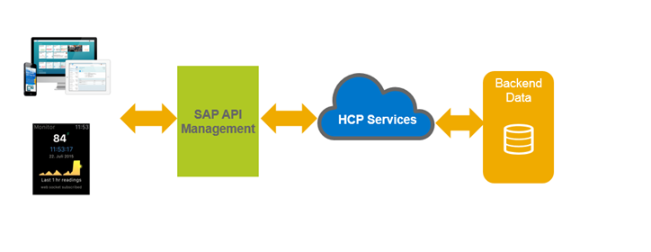
SAP API Management is created to address API needs with features such as API provisioning and publishing, API discovery and consumption, security and access control, analytics and reporting, monitoring, operations and a developer portal. It provides a framework to expose SAP or non-SAP backend data and processes as APIs using REST, OData, and standard SOAP services. These APIs can be used to provide backend content to developers and 3rd party applications to drive commercial transactions and subscription growth.

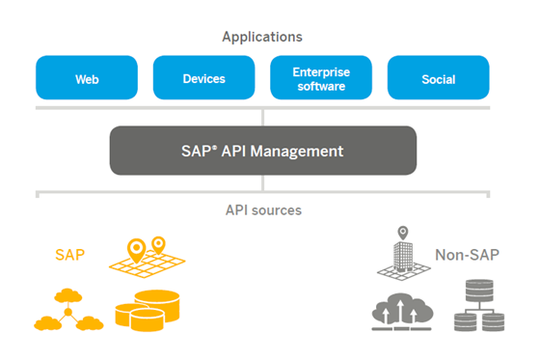
As API Management is running on SAP’s HANA Cloud Platform, it immediately can tap into SAP’s unified cloud portfolio of services, developed apps, and integration capabilities all hosted on SAP’s Cloud infrastructure. In order to maintain the unified experience, SAP API Management integrates with classic SAP On-Premise services that run SAP Gateway via OData. With a built-in discovery feature, SAP API Management can connect to the repository of services already created and expose them as a managed API. It will also capture existing service documentation and include it with the generated API. Rather than app developers consuming services directly, you just access the APIs created using SAP API Management and can create apps without having to know the details about the system you are working on. APIs created using SAP API Management map a publicly available HTTP endpoint to backend services. SAP API Management handles the security and authorizations required to protect, analyze, and monitor your services.

Here is the API-based 4-layer architecture that explains where the API Management layer fits in:

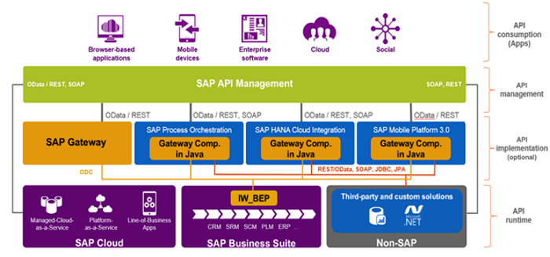
Layer 1: API Runtime is the base layer. Developers create and build APIs from services, which could be anything providing data upon request. E.g. standard SAP on-premise Business Suite Service, a custom database, or some managed cloud service. This is the data which is locked in its own silo, which you are looking to make available in a lightweight, controlled manner.
Layer 2: The next layer, API Implementation, is an optional one. This relates to utilizing SAP Gateway or the reusable component Integration Gateway in order to transform RFCs, BAPIs, or other non-web enabled services into standard OData/REST or SOAP exposed services, which can then be consumed by applications designed to speak OData/REST or SOAP, such as API Management. This layer is optional, and only needed for services which are not natively web-enabled.
Layer 3: SAP API Management is a blanket layer between generation layer and the consumption layer, which is where all the apps live, providing users the powerful front-ends for consuming and utilizing the backend data. The API Management layer’s primary purpose is mediating all communication between these two layers.
Layer 4: This layer provides a single consistent look and feel to all the data it exposes, via REST or OData, so that regardless of what the source actually is, the apps consuming the information need only to know these standard data protocols in order to present them to the users.
SAP API Management consists of 3 high level components:
- API platform – It provides tools to manage APIs and helps in adding, configuring APIs, and managing developers and apps. It helps to create and consume APIs, be it building API proxies as a service provider or using APIs, SDKs, and other convenient services as an app developer
- API analytics – It provides powerful analytical tools to view short and long term real time usage trends of APIs. IP, URL, user ID for API call information, latency data, error data, and cache performance metrics etc. can be collected.
- Developer services – It provides tools to manage app developers. To quickly onboard developers, it provides a developer portal for API discovery of publicly available API products. It provides facility to enforce Role Based Access Control (RBAC) to control access to features of the portal.
Finally, here are some of the main features of SAP API Management:
- Discovery and Consumption – SAP API Management provides API discovery, catalog, subscription etc., making it easy to consume data across all devices and UIs. Complexity is reduced with unified access and governance of APIs across all landscapes. A developer portal provides comprehensive API exploration and documentation.
- API Provisioning and Publishing – Features include API Registration, security and traffic policy definition, protocol definition and mapping, API Availability and Lifecycle Management.
- Analytics and Reporting – Analytics powered by SAP HANA provide real-time visibility on how, who and when enterprise information is accessed via APIs. The analytics provide reports on usage metrics, errors, latency, and performance in a simple, intuitive Web experience. It helps to gain better insights on where to invest your resources in the future. The historical and predictive analytics let you inspect and troubleshoot any issues in the system.
- Security and Access Control – SAP API Management provides policy enforcement, throttling and API Monitoring to aid in scaled and governed access to enterprise information. The security policies provide XML Threat Protection, JSON Threat Protection in addition to Message Validation policy for XML Schemas (XSDs) and WSDL definitions. The mediation policies that can be defined and associated to an API or service enable extraction, filtering and manipulation of messages including headers, URI paths, payloads, and query parameters. SAP API Management supports flexible choice of Authentication schemes such as SAML 2.0, OAuth, Client certificate, API Keys etc. It also provides Role Based Access Control for the Administration of APIs.
- Traffic Management: SAP API Management provides quota policies to manage traffic to the backend servers in order to avoid overloading those servers. It also provides quota calculation at Application Level and Concurrency Rate-limiting and Spike Arrest for APIs.
Thus SAP API Management capabilities enable IT to simplify the way developers go about integrating with their SAP and non-SAP applications, thus reducing cost, fostering co-innovation and increasing participation in the API economy, in a lightweight and cost effective manner.

Section -4
Implementation Plan
  - Understanding of Objectives
  - Proposed Solution
  - System Architecture
  - System Features
  - Proposed Implementation Methodology
  - Approach
  - Project Scope
  - Project Millstones
  - Project Administration Plan

Proposed Staffing Structure

Project Manager
Lead IT/ System Architect
Attendance System Expert / Business Processes Consultant
QA Tester
System Engineer/ Requirement Management Analyst
Support Team
Training Coordinator
Software Developers
Implementation Team Lead

Understanding of Project
- Background
Naufar is a healthcare sanctuary under construction in Doha, Qatar with its primary focus to treat substance related and addictive behavioral disorders along with services for non-cancer patients with chronic pain and comorbid modifiable disease conditions using an integrative wellness approach incorporating medical, psychosocial and physical approaches. An extensive range of hospitality products will be offered including a spa, a gymnasium, restaurants, a conference center and meetings rooms all to be supported by a highly personalized level of service.
The vision of Naufar is:
- To be recognized as a center of excellence within 3 years from opening.
- The mission of Naufar is to:
- Assist people with behavioral disorders to achieve and sustain the quality of life they aspire for, in a healing environment using evidence based practices.
Key features of the sanctuary include:
- Person-centered therapy in a world-class hospitality setting
- Continuum of care underpinned by a therapeutic alliance, tailored to the individual guest’s needs and wishes
- Long-term support to aid the transition to a fulfilling and successful personal, family and work life and the achievement of aspirational goals
- Science-based treatment to take advantage of leading-edge developments now and in the future
- Integrated programs offering medical, psychotherapeutic, wellness and self-help interventions
- Multidisciplinary treatment teams and separate programs for men, women and adolescents
- Integrated leading-edge technological systems and solutions
- The highest professional standards will be the hallmark of Naufar services

- Biometric Attendance Management and Monitoring System
The purpose of this Bio Metrics base attendance system is introducing a transparent attendance system for employees across any organization.
Every organization whether it is public sector or private entity, it has to maintain a proper record of attendance of Employees for effective functioning. Designing a better attendance management system for employees so that records are maintained with ease and accuracy is an important key behind motivating this project. This would improve accuracy of attendance records The system would be based on Cloud based software application supported with Virtual Private Network (VPN) and can be monitored through mobile/computer around the globe. We offer an Innovative attendance system based on Cloud based software application with LAN/WANbased connectivity with Biometrics Fingerprint Device for the time attendance applications. It is be equipped with the fastest commercial-based fingerprint matching algorithm and high-performance, high-image quality optical fingerprint sensor. The screen can display more information vividly, including fingerprint image quality, time/date and verification result etc. This system is on Three Tier Model which includes Remote Machines, Application Server and Database Server. Virtual Private Network makes it easy to secure all the transmission on the internet.
With high speed processer at device level and optimized fingerprint recognition algorithm, system should offer the best recognition rate. This biometric fingerprint attendance system stores fingerprint data and employee details. User time-in, time-out and attendance logs are stored in the server. Administrators could interact with data being sent using this device through the central server. All departments and sights would be connected through LAN connectivity with the server. Authorities would be able to access this system through their android smart phone and computer systems. Only authenticated users would be able to connect with the Biometric Attendance System’s reporting application.
Thus the system offers enterprise level of Entry and Time Attendance management with its LAN communication-based infrastructure enabling integrated monitoring and systematic management through multiple terminals operated independently on remote locations.

The system shall have functionally the following properties:-
- The system registers an employee and stores its fingerprints through a biometric fingerprint system.
- It then identifies an employee by matching the fingerprint of an employee to the one it has stored through the fingerprint registration process.
- The system is based on the fingerprint biometric, record the date and time of the fingerprint impression of the employee and store the ID, date, time and other relevant information in a database system.
- The system does this for both in-time and out-time.
- The system generates and sends attendance summaries, alerts, leave request, leave approval status through SMS to all stakeholders and management
- The system is able to display and print the attendance information to the authorized staff at the local site. More over the attendance data recorded through the fingerprint biometric system should be sent / synchronized with a remote/central database server; where all the attendance data will be consolidated.
Scope of work is divided into three major components:-
- Provision, Installation and configuration of Bio Metrics machines.
- Scanning & Training to make attendance system operational.
- Integration with SAP Database
- Development, Configuration of centralized Attendance Management and monitoring system to receive all locations data to produce desire reports.
In first part of “Provision,Installation and configuration of Bio Metrics machines at all identified sites” would be installed. STEPNEX SERVICES will produce deployment and configuration plan with seven days after the issuance of Purchase Order by Naufar . Any specific arrangements to install Bio Metrics machines at all sites will be communicated in writing along with deployment and configuration plan. A safety and operational guideline document will be placed with all Bio Metrics machines for safe and trouble free operation. This document will contain the contact information for in case of any operation / functionality / warranty problem. Upon communication of any problem by Naufar, unique ID to the problem will be issued by the STEPNEX SERVICES and problem will be resolved within 36 hours.
Monthly report to Manager MIS will be submitted for all complaints received during the month and their resolutions status. This report will also contain the lessoned learned during the month and any suggestion to improve the system. All locations, where two bio metrics machines will be installed, will share common database of Bio metrics scans. The purpose of this sharing would be that any user can login on any machine for time-in and time-out. In case any problem with one machine, attendance system must continue working with one machine unless problem is resolved for the second machine. In this phase all activated SIM’s will be inserted into the machines and network coverage will be checked for data communication with centralized server at Naufar -Qatar.
In the second part “Scanning & Training to make attendance system operational” phase, a person on each location will be nominated by the Naufar for bio metrics scanning on that location and for assistance in all operations for this project. This person will be trained during the installation and configuration. Nominated person and responsible person on each location will receive this equipment (Bio Metrics Machines) and issue satisfactory report of initial configuration and deployment.
The third portion is “Configuration of centralized system to receive all transmitted data to produce desire reports”. Desire reports and functionality of the system has been mentioned in detail in the document hereafter. Centralized administration to control and monitor all bio metrics devices from Naufar Head Office Server will be demonstrated. Configuration of centralized server to connect all locations bio metrics machines for data connectivity, transmission and centralized administration to change password and other activities will be the responsibility of the organization. Required software environment to support the whole application will be provided by STEPNEX SERVICES to Naufar MIS department for arrangements. Naufar will arrange server hardware; operating system and required patches / environment to run centralized web application and bio metrics machine connectivity at Naufar Head Office.

In summary of scope of work includes: -
- Provision, Deployment, Installation and configuration of all Bio Metrics Machines in the designated areas.
- Training of Staff to run the system.
- Development, Deployment and Configuration of centralized MIS Attendance Management and Monitoring system to received data transmitted by all Bio Metrics Machines.
- Ensure operational assurance for one year and subsequently through SLA (if approved)
- Ensure automatic data transmission using LAN between Bio metrics machines and centralized system
- Ensure availability of data through web based attendance management system and on smart phones / normal phones.
- Logging of all received complaints and efficiently and timely resolutions of all these complaints.
- Demonstrate all required functionalities as per Naufar tender requirements.
Operational Assurance
STEPNEX SERVICES will provide one year operational assurance with this this project. Operational assurance means that all devices at remote locations are in working satisfactory and successfully transferring data to centralized system without trouble / hassle. STEPNEX SERVICES will ensure that all desire reports, mentioned in this document hereafter are being produced, keeping in view various security levels and user rights. The organization will propose a detail plan to achieve this target.
To ensure redundancy at centralized system, STEPNEX SERVICES will also propose a backup plan in case the main system goes down due to any reason to continue attendance system working assurance.

CENTRALIZED ATTENDANCE MANAGEMENT AND MONITORING SOFTWARE
STEPNEX SERVICES will provide centralized web base attendance management software to capture all system attendance data and produce desire results and consolidated reports. Attendance management software tools would be Open source Technology whatever agreed.
Source code of application along with administrative security passwords after the successful deployment of the software will be provided to Naufar’s MIS Department. Here is the basic flow of the desire application.
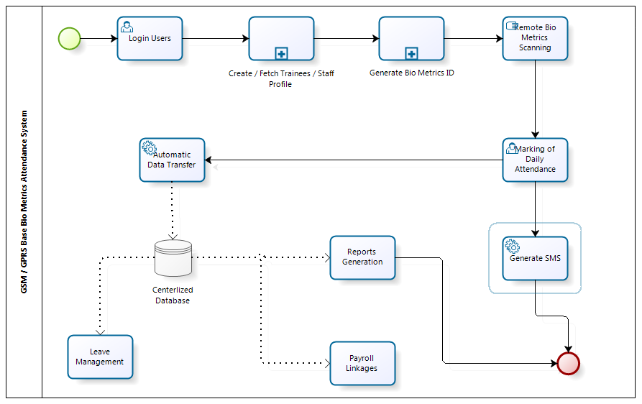

- In Step 1: Application will allow creating user with security rights. User rights will be application administrative level privileges, Bio Metrics code generations, making of leaves, marking of manual attendance in case of any problem, creation of trainees profiles into system or fetching / linking of trainee profile from any other application and users self-service portal to view his monthly attendance, leave status and apply online leaves. Online approval of leaves will also be part of the system.
- After login, application will allow users to create / fetch / link staff and trainee profile. Staff profile for Naufar will be created by Naufar HR Department .Once profile for Staff and trainee is created into system and then system will automatically generate an ID for each staff and trainee. This ID will be used by the remote Bio Metrics machine users to scan bio metrics for attendance. This process has been further elaborated in below diagram.
Scanning of bio metrics at remote location is required to be controlled process. Centralized administration of Bio metrics machines to control scanning and changing of password is required. Any similar procedure for controlling illegally scanning and time bound scanning can be acceptable upon mutual consent.
- After Bio Metrics scanning, daily time-in and time-out will automatically be transferred by the Bio Metrics machine to centralized server system using LAN communication infrastructure.
- At the parallel time-in and time-out data sending process by Bio Metrics machine, one to three SMS with short description message will be generated on given numbers by the Bio Metrics machines automatically.
Following capabilities of attendance management software are offered:-
- Include Naufar organization structure for information access through security privileges for the HR Office, Different Departments and Area Offices
- Digital Dashboard for Naufar, Departments and Area Management for attendance analytics. This dashboard will include graphs, tables and other charts.
- Separation of Staff by departments into Software.
- Naufar / Department Wise / Area Wise Consolidated daily attendance report for staff and trainees.
- Naufar / Department Wise / Area Wise Consolidated attendance report for staff for a particular period
- Department Wise, Trade Wise and Batch Wise attendance report.
- Individual Staff Member Daily / Weekly / Monthly Report
- NAufar / Department Wise / Area Wise / VTI Wise / Consolidated monthly attendance register for staff and trainees.
- Daily Bio Metrics Data receiving status
- Monthly Bio Metrics Data Received status
- Marking of Leave Options for Staff and reflection of leave into all reports
- Naufar Leave structure induction for all staff members
- Centralized holiday’s calendar. This will be maintained by HR Department of Naufar and will be applicable to all staff members through the application.
- Recording of Staff Profiles for report generations
- Marking of Staff active and inactive status
- Separate reports for staff a inactive status (Daily, Weekly, Monthly, Quarterly and Yearly basis)
- Based on the attendance HR strength report (Daily, Weekly, Monthly, Quarterly and Yearly Basis)
- Induction of Staff’s Departments and Batches for Employees.
- Overall Department wise Attendance (Daily, Weekly, Monthly, Quarterly and Yearly Basis)
- Consolidation summary report for staff monthly payroll calculation (Department Wise, Area Wise / or individual staff member wise.
- Induction of HR department designation / grades structure into staff profile
- Multiple Timing Calendar to accommodate different timings, shifts for NAufar, Regions
- Staff Location updated facility in case of any transfer on any location / department / region and area.
- Staff Profile updating option in case staff member is promoted.
- Early and Late report for for daily, weekly / monthly and yearly frequency
- Facility to store staff digital picture into software
- Staff profile fields will be discussed separately and base on fields any additional report can be included.
- Different consolidated reports based on the existing data of database.
- Enable / disable SMS features
- SMS sending nos. for a particular employee attendance report.
- SMS generation or any other number automatically.
- In case night shift or date difference, adjustment of attendance timing.
- List of time in marking but no time out marking.
- Applying and approving of Leaves for staff through application.
- Organization Logo and location for all reports.
- All above requirements are based on initial working and brain storming. Minor change into software can be required during detail analysis and reports format finalization phase.

Some Screen Shorts
Login
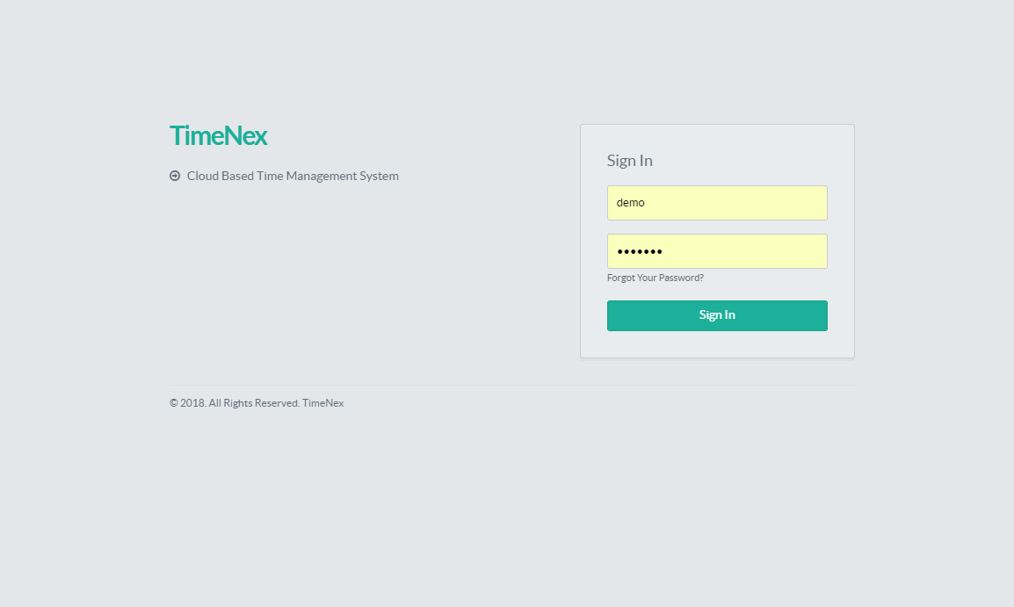
Dashboards
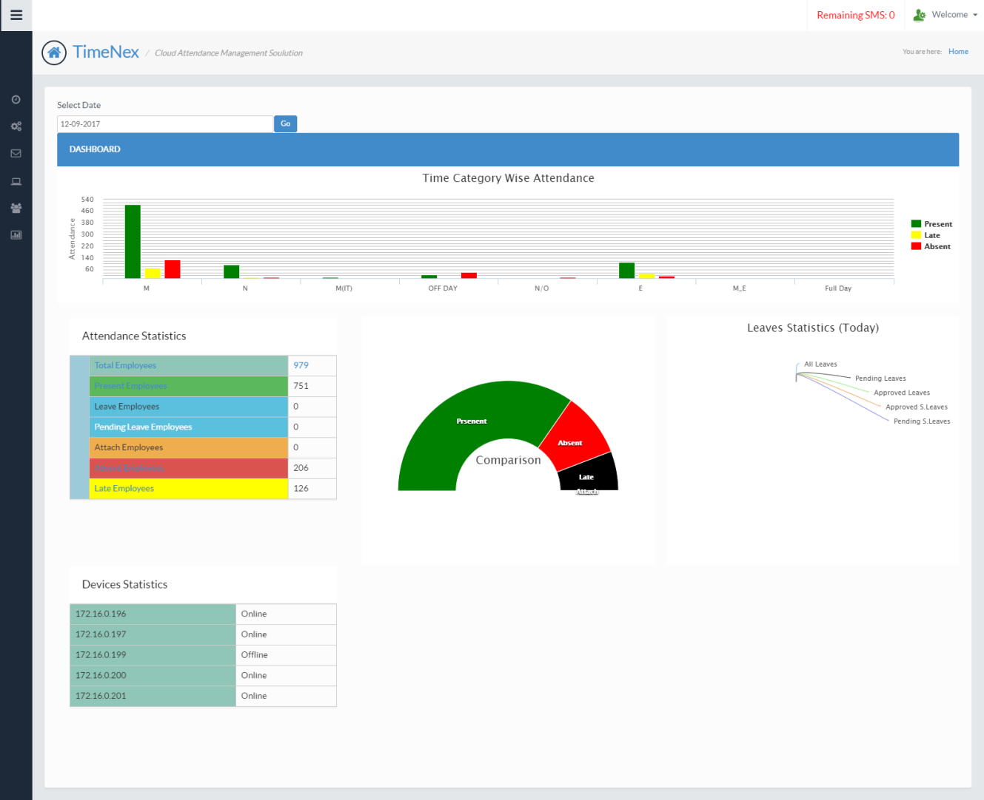

Add Time category
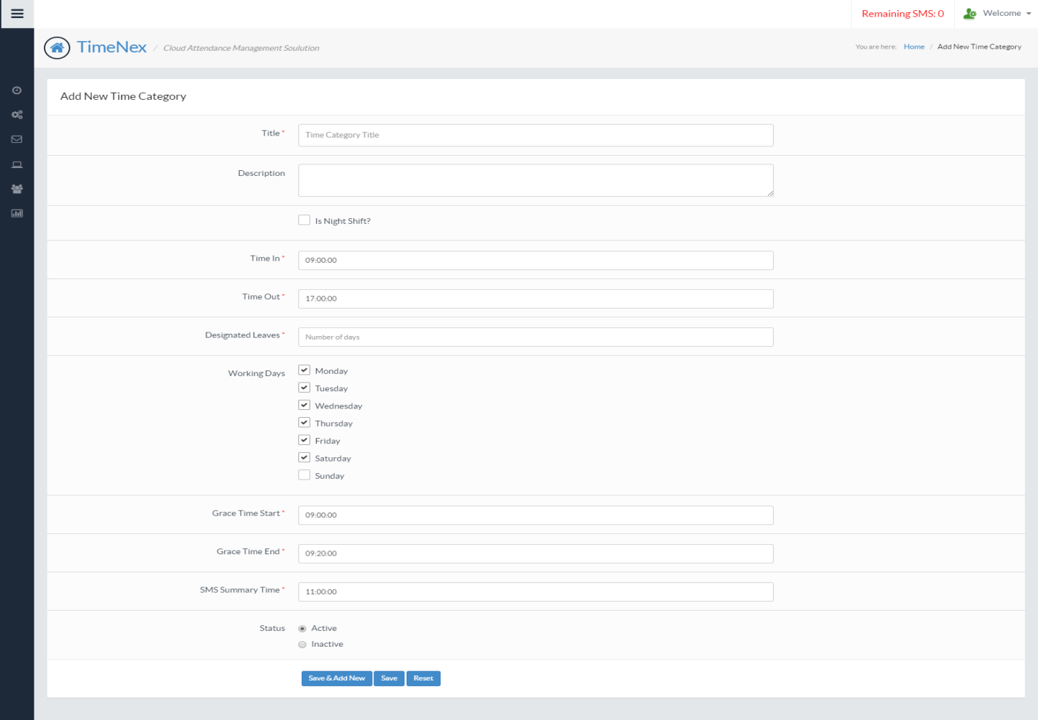
Attendance Report
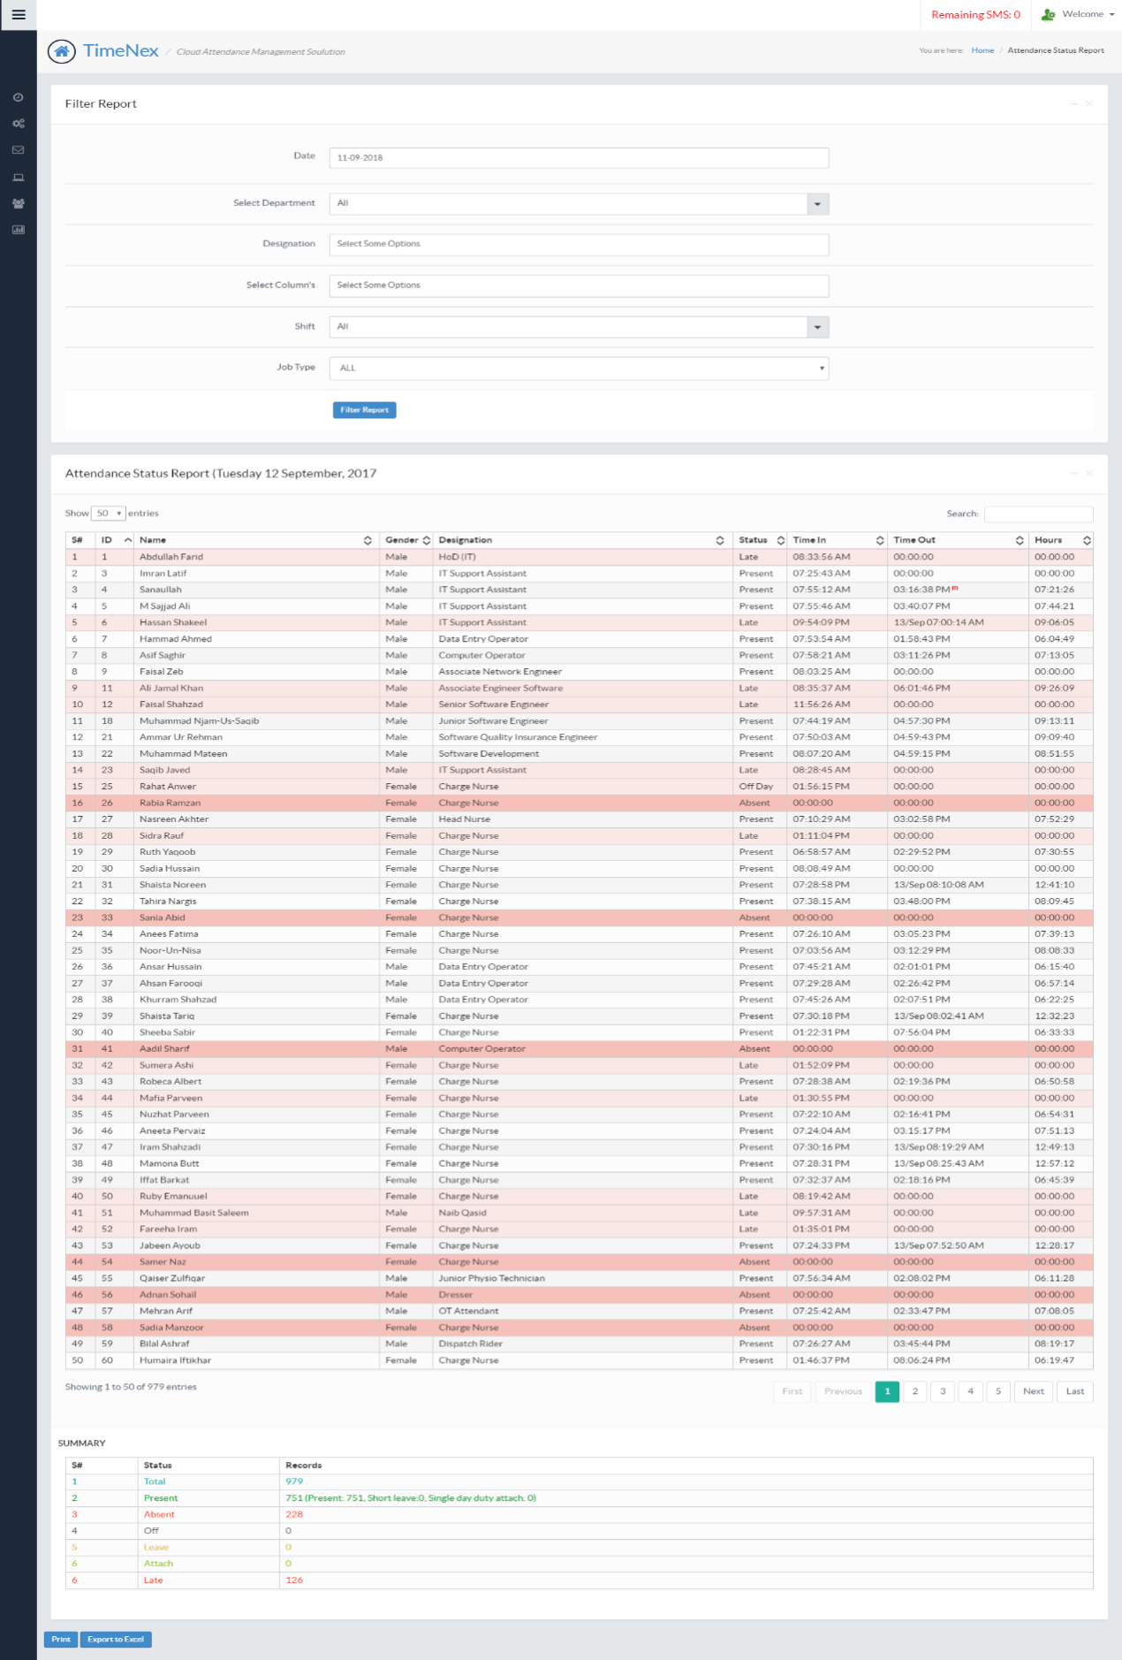

Roster Assignment
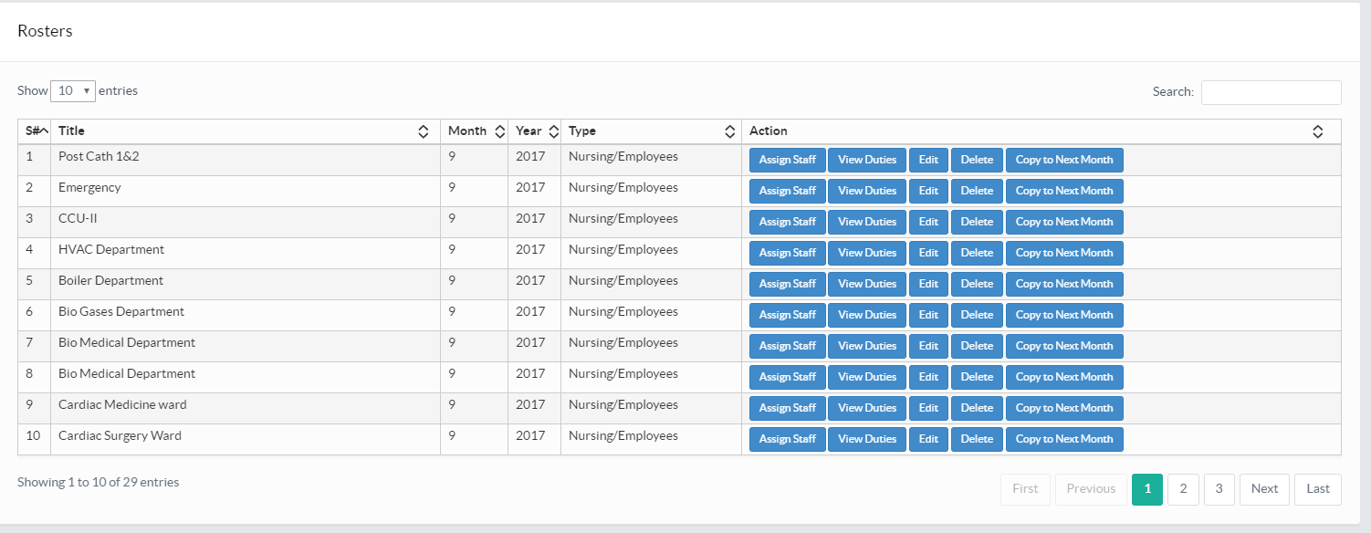

Roster Duties
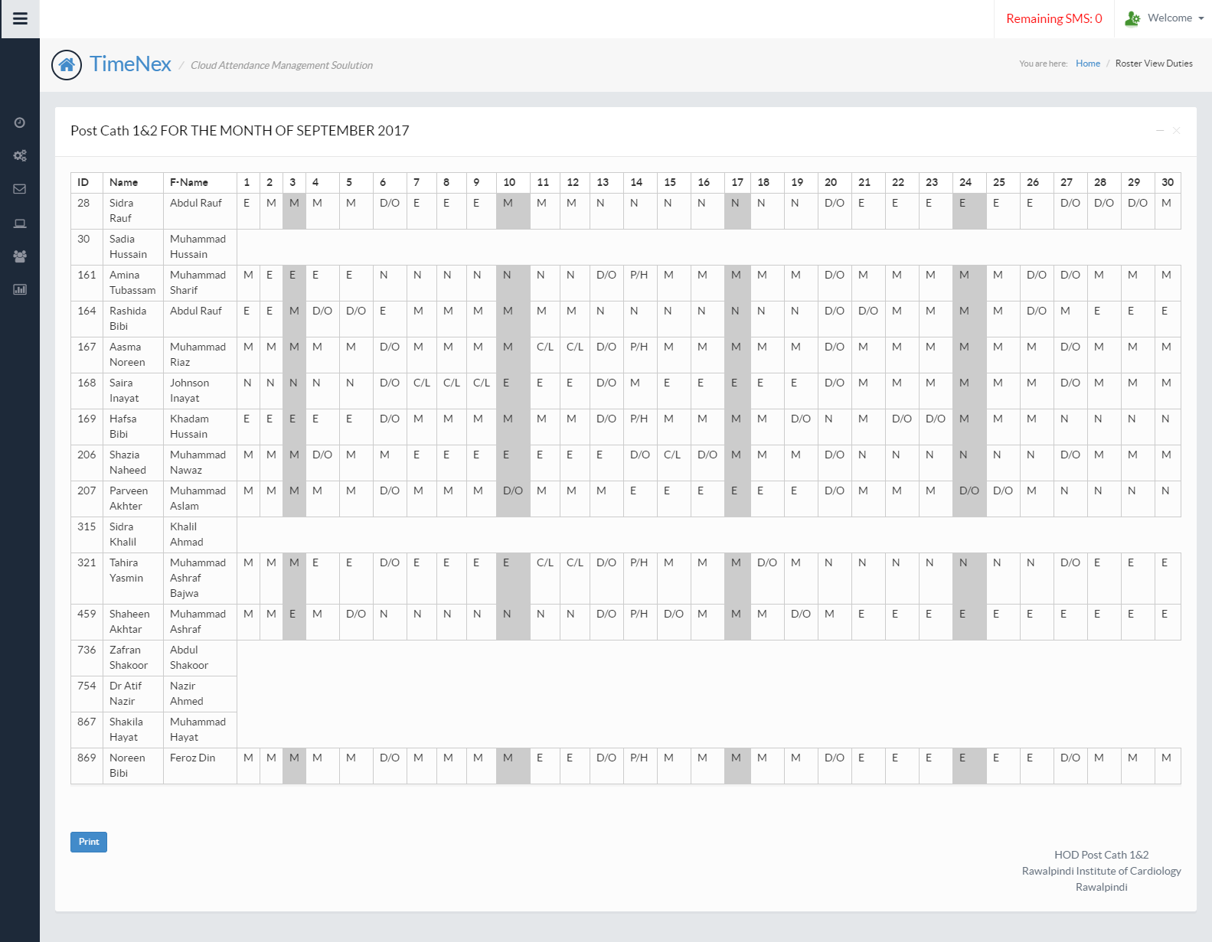

Times Slots Allocations
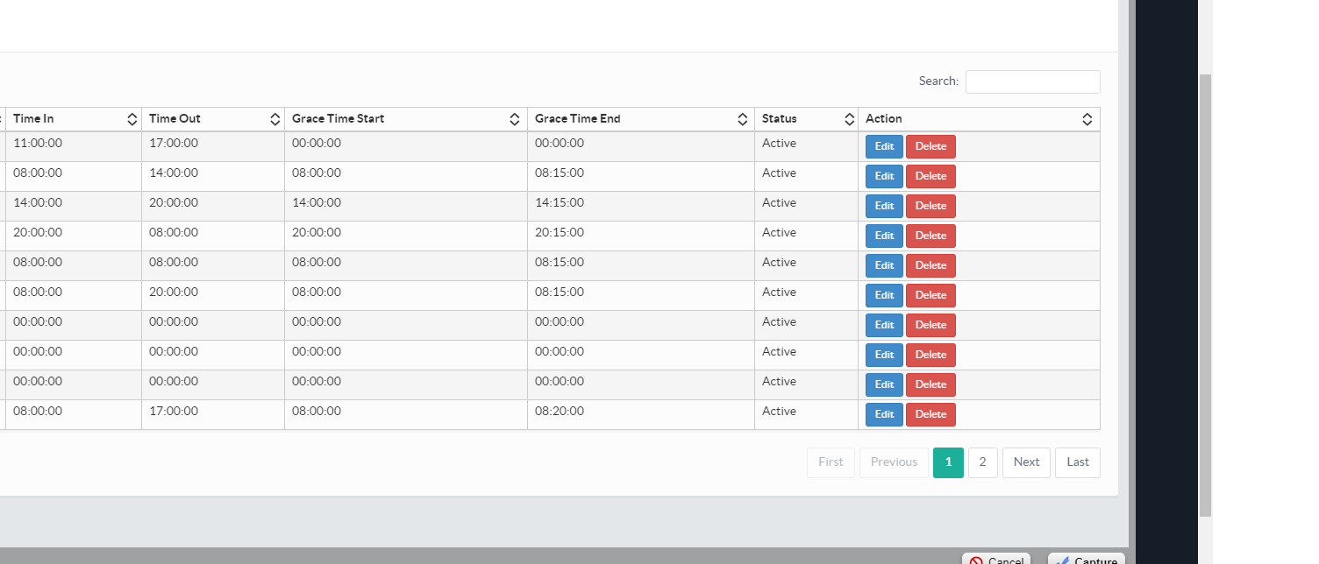
Roster Management


System Architecture
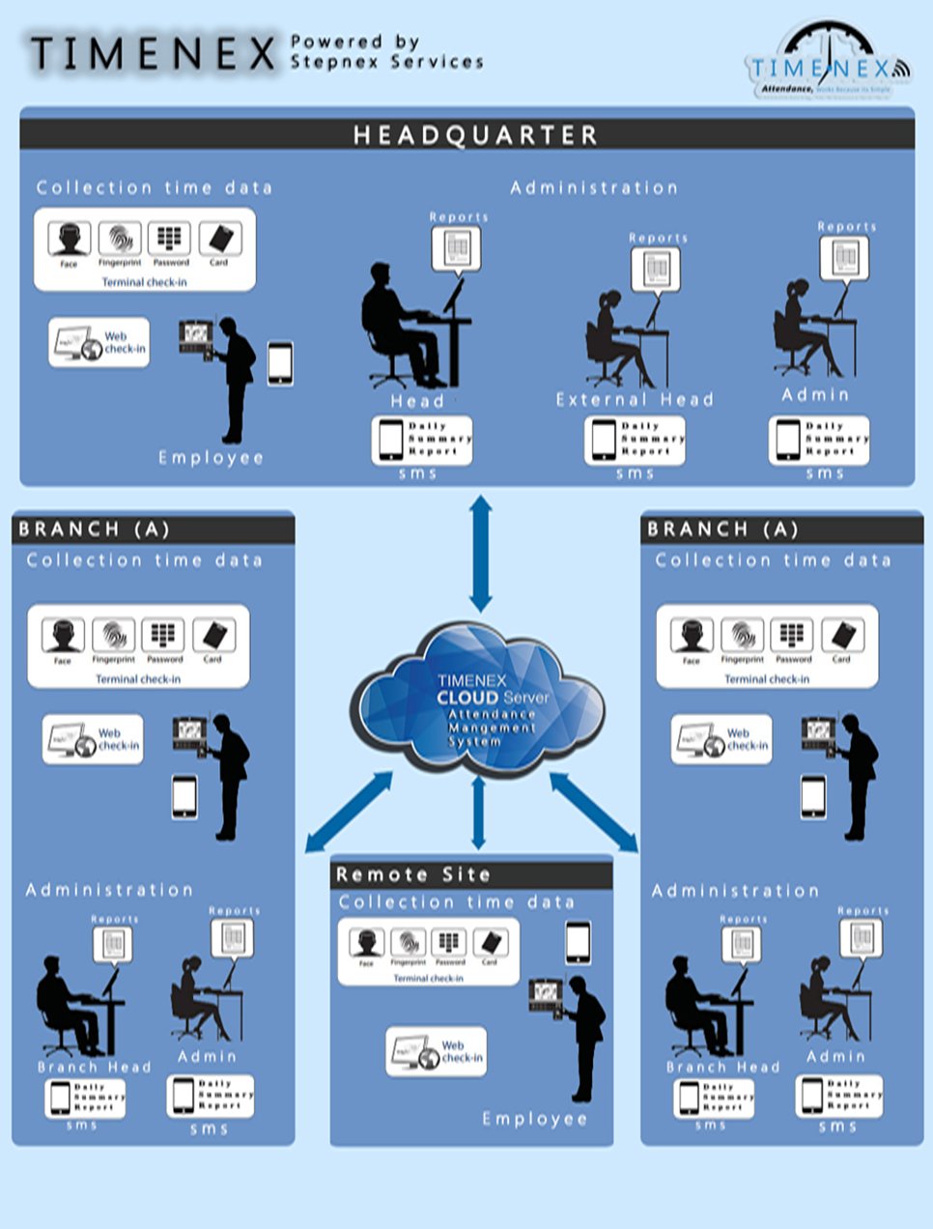
Proposed Implementation Methodology
The following step-wise approach would be carried out for implementation of this project:
Phase-I:
- Survey and Study of Current/Existing Systems and Sites identified by HR -Naufar
- Detailed System Design and System Architecture
- Process Flows and Functional Specification Requirements
- Systems Deliverable Plan
Phase-II:
- Delivery and Installation of Biometric Devices and allied accessories
- Deployment and establishment of Infrastructure
- Deployment and establishment of ICT/Datacenter Infrastructure
- Development of templates and analytical reports
- Customization of off-the-shelf Developed Software System
Phase-III:
- System Tested and Quality Assured
- System Roll Out
- Pilot testing
- Complete Documentation
- Support Service

System Analyst along with Implementation Team Lead would conduct the survey for identification of INPUTs. Also, templates for collection of data against Software development and infrastructure deploymentwould be developed to be filled out by the council. For this purpose following activities would be performed:
- Consultations would be conducted with the concerned institutions to recommend the sort of information/ data to be placed on the datacenter for attendance operations.
- The sort of technology, ICT Infrastructure and Data Centre Technology for Attendance Management through consultations of stakeholders in the client vicinity would be analyzed for Software Development or Customization of the off-the-shelf application.
- The approval of the HR Department-Naufarregarding the type and format of turn-key solution would be sort out.
- On completion of phase-I& phase-II following reports/documents would be produced:
- Meta standards and guidelines
- Infrastructure Development Plan
- Data management guidelines
- Technology requirement plan.
- Data Collection template
- Develop Training Plan
- Develop Support Plan
- Develop disaster, recovery, and business and resumption plan. Develop risk assessment and management plan

On the basis of the findings of Phase-I, indicating methodology, approach and techniques to be applied for system requirement and specification document and Functional Specification Requirements to be developed.
On successful customization and pilot testing the focal persons (one from M/s Stepnex and one from client) would sign a go ahead signal for implementation. On successful completion and verification of the clientthe application would be rolled out and client will issue a completion certificate.

Approach
Due to the nature of the project the major issues in the execution of the project will be coordination with stakeholders, identification of requirements, timely post implementation and proper resource utilization. Whereas overall project management/coordination will be the responsibility of M/S StepNex Services Pvt. Ltd.
Project Preparation
In this phase a project plan would be prepared and foundations would be laid for successful implementation. At this stage strategic and crucial decision of the project would be made keeping in view the following:
- Define project goals and objectives
- Clarify the scope of project implementation
- Define project schedule, budget plan, and implementation sequence
Business Blueprint
In this phase a project blueprint would be created which will document enterprise’s requirements and establishes how business processes and organizational structure are to be represented in Application. Also original project goals and objectives would be refined and overall project schedule would be revised in this phase, if required.
Realization
In this phase, configure the requirements contained in the Business Blueprint. Baseline configuration (major scope) is followed by final configuration (remaining scope), which can consist of up to four cycles. Other key focal areas of this phase are conducting integration tests and drawing up end user documentation.
Final Preparation
In this phase preparations would be completed, including testing, end user training, system management, and cutover activities. All open issues would be resolved in this phase. At this stage it would be ensured that all the prerequisites for Application to go live have been fulfilled.
Go Live & Support
In this phase project moves from a pre-production environment to the live system. The most important elements include setting up production support, monitoring system transactions, and optimizing overall system performance.

Deliverables

The table below shows the major deliverables in the project.
Sr. No. |  | Title of Deliverables | Indicators
 | 1 | Phase-I:  - Survey and Study of Current/Existing Systems and Sites identified by HR Department-Naufar  - Detailed System Design and System Architecture  - Process Flows and Functional Specification Requirements  - Systems Deliverable Plan | SRS document is produced which includes;  Cases used, Description of Attendance System Model, Datacenter Model, Functional requirements, Non-functional requirements, Interface requirement etc.  Flow of data with accuracy and consistency.  Deliverable plan followed.
2 |  | PASE II  System Delivered, Deployed and in production ( according to the agreed deliverables plan)  Following deliverables included but not limited to:  - Delivery and Installation of Biometric Devices and allied accessories  - Deployment and establishment of Infrastructure  - Deployment and establishment of ICT/Datacenter Infrastructure  - Development of templates and analytical reports  - Customization of off-the-shelf Developed Software System | Plan implementation.  Customization of the off-the-shelf system or development of a new system.  System Roll Out.
3 |  | PHASEIII  Phase-III:  - System Tested and Quality Assured  - System Roll Out  - Pilot testing  - Complete Documentation  - Support Service | Checking of the relevant data entered. Quality accessed. Usage Documentation for data entry staff.
 |  | Expiry of Warranty | Guaranteed
Note: Project duration could be managed within the stipulated time frame.
Work Plan & Timelines
The below given table entails the deliverables of the project and the expected optimistic time these deliverables are going to take. The project will be LIVE before end of December 2018.
Overall Project Work Plan & Timelines
Task | Deliverables | Months
 |  | 1 | 2 | 3 | 4 | 5
1 | Detailed System Analysis and Preparation of SRS
2 | System Design:
3 | System Development and System Testing
4 | Provision, Installation of Biometric Devices
4 | System Implementation and Acceptance:
6 | Staff Training
7 | Supply user manuals with standardized procedure and formatting
8 | Maintenance & Support of Application Software

NOTE: STEPNEX SERVICES Systems implementation team believes that we can save a lot of time through better coordination with the client team.

Project Management & Administration Approach
Majority of projects that fail, do so from a failure in leadership. As a result we have worked diligently to recruit and train top quality service and project managers with significant experience to support their development and infrastructure engagements. The information contained throughout this section will enable client processes that will be used in order to achieve the goals identified above. It is important to note that we have been successful in truly partnering with our clients and other vendors to create solutions that provide the most value for our customers. Our unique ability to partner in a project effort means that our customers obtain an industry leading solution and gain the necessary capabilities to support their ongoing environment.

Communications Management
Project Communications Management includes the client processes required to ensure the timely and appropriate generation, collection, dissemination, storage, and ultimate disposition of project information. Communication provides the critical links between people, ideas, and information that are necessary for success. Everyone involved in the project must be prepared to send and receive communications in the project language or semantics and must understand how the communications they are involved in as individuals affect the project as a whole.
Communications can often times make or break a project. If critical information is not flowing correctly among the project teams, project issues can incur in the successful completion of the project.
For managing the scope of project documentation, we recommend establishing a Project Communications channel that clearly defines the users of information, the frequency of information, project meetings and the content and context of information during the project. In addition, a project central repository will be recommended which facilitates the storage, review and retrieval of all documents related to the project.
Key elements of communications planning will include regular, timely and accurate information regarding the project status, progress, activities, issues, risks, staffing, changes and completion. Strong communications management will keep the executives and project sponsors informed in a timely manner to make appropriate business and project decisions and will coordinate project team and client.

Schedule Management
Project Schedule (Time) Management includes the Client processes required to ensure timely completion of the project. The typical process for deriving scheduled delivery dates follows an established Client procedure. Project Manager will identify phases, sub-phases, activities and tasks within the scope of the project. Schedule work plans will be maintained throughout the life of the project using Microsoft Project. This process will compare actual project progress to plan on defined intervals. Schedule information will be communicated to the client with Issues, and risks with their prioritization through the above described Communications framework.

Issues Management
Problem and Issues occur in every project. Appropriate issue identification, analysis, resolution and escalation processes are vital to ensure that issues have minimal impact upon project objectives, cost and schedule.
Project Issue Management includes the processes concerned with identifying, analyzing, and resolving project issues. Issue management works with the Communications framework to ensure that issues are escalated, resolved and resolution is communicated to appropriate stakeholders in a timely manner. Issues may or may not trigger project risks that could have a serious impact on the project. Early identification and rapid resolution is the key to successful issue management.

Risk Management
Project Risk Management includes the processes concerned with identifying, analyzing, planning and responding to project risk. It includes maximizing the results of positive events and minimizing the consequences of adverse events.
We advocate a proactive risk management approach, meaning the project team has a visible process for managing risks in a measurable and repeatable manner. With proactive risk management, the team assesses risks continuously and uses this information to make decisions in all phases of the project. The team carries risks forward until it resolves them or it handles them if they emerge as problems. At a minimum, a project manager should ascertain and document the level of risk and the effect of that action on the project.
For detail risk management plan refer to Risk Management Plan in Proposed Methodology.

Scope and Change Management

Project Scope Management includes the processes to ensure the project includes all of the work required, and only the work required, to complete the project successfully. Scope Management is primarily concerned with defining and controlling what is or is not included in the project. The major scope management process includes the following:

Initial Scoping- this document specifies the initial scope of the project and defines boundaries of the solution.

Documenting Customer Requirements– A formal document regarding project requirement will be formed after the series of interviews with the client.

Scope verification– formalizing acceptance of the document by the client

One of the key functions of program management is planning and executing the project’s Change Management. Tracking changes to the project’s scope, feature, functionality, documents and technical artifacts provides an essential and effective means to delivering a successful end solution. Change Management process begins with this very documents acceptance where the initial boundaries for the project are specified.
The program management team is also responsible for the creation of the Change Control Board (CCB). This team functions as the decision authority for accepting or rejecting changes to the current baseline configuration.
Project Trade Off
The variables in any project are resources (including people and money), schedule (or time), and scope (including features, functionality, the product and its quality). As the team develops a solution, it will inevitably have to make tradeoffs among these project variables. The key to project success is finding the right balance among resources, schedule, and features.
Schedule
Resources
Scope
The major project variables can be viewed as having a triangular relationship. After the team has established the triangle, any change to one of its variables (or sides of the triangle) requires a correction to at least one of the other variables to maintain project balance.

Project Quality Review
To help ensure project success we provide project quality review staff, outside of the core project team of objective analysis. While the project team lives and breathes the solution every day, outside resources bring a new perspective to the team, often recognizing ways to identify and mitigate risk, escalate product issues, or apply the appropriate resources to ensure success.
Project Quality Review will help ensure the key deliverables and criteria of the project are being addressed, documented, managed, and on-target to meet the project’s critical success factors. The progress reviews will be scheduled at the end of the design phase and completion of the development/implementation phase. The separate Internal Quality Audit department on regular intervals to ensure that we live up to its reputation also performs internal Quality Audits.

Acceptance Management
We are keenly interested in the satisfaction and delight of our customer’s and pays close attention to conditions and criteria that will lead to highly satisfied customers and timely adoption and deployment of technology solutions. We understand that high satisfaction is gained through planned excellence and making sure those Client criteria is clearly defined early. We will work with Directorate to establish clear criteria and conditions for success.

Technical Specifications:
TECHNICAL SPECIFICATION

Item No | CATEGORY | Specification | Qty
No.01 | FingerTec TA100C  (Broacher Attached) | - TCP/IP enabled with Ethernet/Wi-Fi connection (or optionally GPRS in cases where there is no LAN access.  - Support local in-memory storage or on external expansion (flash) card for storing 10000 Fingerprint templates 20000 transactions data.  - Reliable and long-life optical scanner with high pixel resolution and DPI.  - Have LCD Screen, Battery backup. Should support both 1:1 and 1:N modes  - Accept Fingerprint placement at any angle.  - Registration Method: Fingerprint, RFID and Password  - Identification Mode: Finger Print, RFID Card, Password and multi-combination  - Separate Beep on successful / fail fingerprint identification  - Visual alerts for successful / fail fingerprint identification like green / red Leds etc.  - Maintain time and date automatically without any external power8  - LCD Display  - Optical Fingerprint Scanner  - Verification Speed < 1 Second  - Scanning Speed < 0.5 Second  - Speaker – Voice Prompt  - FAR (False Acceptance Rate): < 0.001 %  - FRR (False Rejection Rate): < 0.1%  - Working Temperature: 0 C – 60 C  - Working humidity: 20 % - 80 %  - Working Code: At least 8 Digits / Character | 2
 | Software | Web-based software capable of communicating with several clients in real time featuring:  - Add/remove/restrict/configure terminals.  - Employee enrolment.  - Adding holidays and holiday types.  - Overtime and Vacations time.  - Attendance Rules.  - User Management.  - Capability of generating different detailed and summary reports like in-time/out-time wise, Employees wise, Department/Section/Shift wise, Day/Week/Month/Year wise, Temporary in/out wise, Location wise report etc.  - Security features like read-only database to administrators and remote logging on any attempted change to the database. | 1
 | Warranty | - One Years for Parts, Labors, onsite Services.  - Hand to hand replacement warranty in case of warranty claim.
 | Operational Assurance | - Six Month Operational Assurance  - Deployment & configuration as Required

Section -5
E N V I R O N M E N T & C O N S T R A I N T S:

Environment
Project environment is the context of project execution factors and understanding the project environment is essential to keep the project in control by focusing on triple constraints i.e. Scope, Cost & Schedule.

Application & Execution Constraints
While developing the applications & execution plan following have been kept in consideration.
- Requirements of the Users because well-defined user requirements leads to project success.
- Users’ acceptance of the new system may create hurdles because users resists for the implementation of new system.
Coordination and communication are the most important factors.

Constraints
This project is assumed to run under following constraints
- Communication Constraint
Poor Communication might cause slight schedule slips or cost over runs.
- Implementation Plan Constraint
Changes in the implementation plan may cause delays.

Manifested Strategy
Strategically, our success comes around:
- With our project counter parts we reduce Communication Constraint through a Communication Plan. Poor Communication might cause slight schedule slips or cost over runs.
- Implementation Plan Constraint
Changes in the implementation plan may cause delays. We deploy a practical Implementation Plan through a controlled Change Management System.
- We create a working environment where we enjoy the success stories.

Section – 6

Risk Management
Project Risk Management includes the identifying, analyzing, planning and responding to project risk. It includes maximizing the results of positive events and minimizing the consequences of adverse events.
We advocate a proactive risk management approach, meaning the project team has a visible approach for managing risks in a measurable and repeatable manner. With proactive risk management, the team assesses risks continuously and uses this information to make decisions in all phases of the project. The team carries risks forward until it resolves them or it handles them if they emerge as problems. At a minimum, a project manager should ascertain and document the level of risk and the effect of that action on the project.
Although the risk management and mitigation is an ongoing process in project execution life cycle, and our project management keeps a proactive approach in this regard. Below are some of the risks that we have learned about in execution of similar kind of project in similar environment.
- Coordination risks
- Infrastructure risks
- Acceptance risks
- Technical risks
Below is the Risk Assessment and Management Table for each of the above mentioned risk
Risk Type | Risk and Description | Risk Chance | Risk | Risk Owner
Coordination | This include all kind of risks that may be caused by poor coordination with all the stakeholders | Medium | High | Project Director
Infrastructure | This include all the risk caused by poor Infrastructure like unreliable electricity etc. | High | Medium | Infrastructure Team Lead
Acceptance | This include all the risks that may be caused by the resistance of the stake holders in accenting the new installation | Low | Medium | Project Director
Technical | This include all the risks that may be caused by poor execution on part of technical staff | Low | Low | Web Developers Team Lead
Quality | This include all the risks that may be caused by the Poor Quality Control | Medium | High | Web Developers Team Lead / Client
Payment Delays | This may include the Payment delays on part PTVC | Medium | High | Project Director/ Client
Training | All the risks related to Training | Medium | Medium | Training Team Lead / Client

SECTION: 7
T R AN I N I N G & Q U A L I T Y M A N A G E M E N T:

Quality Road Map
Being a projectile organization our focus is to deliver the services & products as per standards set by leading benchmark bodies & organizations including ISO for quality management & PMI for project management. We will make use of ISO 9001:2000 to assure the quality of the services & products. We have set processes to ensure the quality of services during support period and staff training. All the processes & activities are measured against defined quality management plan & monitored regularly by the quality assurance processes. All these processes are based on ISO & PMI quality architecture, in turn making sure that our projects are as per user requirements, on time, within budget and confirms to the quality plan.
To help ensure project success we provide project quality review staff, outside of the core project team of objective analysis. While the project team lives and breathes the solution every day, outside resources bring a new perspective to the team, often recognizing ways to identify and mitigate risk, escalate product issues, or apply the appropriate resources to ensure success.
Project Quality Review will help ensure the key deliverables and criteria of the project are being addressed, documented, managed, and on-target to meet the project’s critical success factors. The progress reviews will be scheduled at the end of the design phase and completion of the customization/implementation phase. The separate Internal Quality Audit department on regular intervals to ensure that we live up to its reputation also performs internal Quality Audits.

Training Plan & Capabilities
The Training plan shall identify the activities, resources and timelines associated with the end-user training, including the Training presentation, User Manual content and format, and on-site end-user training sessions.

Below istheTraining Plan &activates for staff training;
Training Plan
Develop training plan
Develop training materials
Finalize trainees with the client
Schedule training
Develop training delivery mechanism
Deliver training

SECTION: 8
S U P P O R T P L A N:

Support Objectives and Assumptions
The Support Plan outlines the support strategy for Client to undertake:
  - Secure system to use.
  - Automated and Caller friendly call center.
  - Dissolve the manual documentation make it completely online and accessible over the internet.
  - Understandable hotline and datacenter management.
  - Overview of individual company’s performance.
The document will guide project stakeholders to successfully operate and maintain the system established under the said project.

Support Objectives
The key objective for support is to ensure that the systems installedmustrun error free to achieve the project objectives and provide reliable and better facilities to the client and to the satisfaction of all the stakeholders. Support system also helps to adapt to new technology user’s needs.

Support Assumptions
In order to carry out the support of the system successfully, the following assumptions need to be adhered:
- The system will be established and run.
- Professionals are staffed for maintaining and operating the system
- Supported by upper management
- Error/Bug fixing must be in place.

Support Strategy and Environment
The systems are supposed to be run for a long time. The Home Department will provide support in this regard.

Support Strategy
- Minor Problem:Sufficient training will be provided by the company to the client staff so that they can perform minor trouble shooting them self. However if possible the minor problem can be solved by phone, and team can be deployed to the location if possible.
- Major Problem: Upon need of this kind of support activity, proper support plan will be executed. Support Manager will analyze the situation, create the support plan, assign tasks to support members, and deploy the team to certain location.

Support Requirements Determination
Support Requirements will mostly be determined by the client staff and intimated to the concern support manager of the company. It will be the job of support manager to determine the support requirement type, response mechanism & action to be taken to resolve the issue.

Support Environment
In order to provide the support it is very important that the support environment may be clearly defined and under stood. It is our understanding of support environment:
  - Secure system to use.
  - Automated and Customer friendly issuing centers.
  - Dissolve the manual documentation make it completely online and accessible over the internet.
  - Understandable data management.
  - Overview of individual company’s performance.

Support Responsibilities
Stakeholder | Responsibility
Company: | Provide sufficient training to the concern staff so that minor support activities can be performed first hand.
Client: | Provide administrative help so that the support activities can run smoothly.
User Staff | Identify support requirements and quarantine the situation so that further break can be minimized and intimidate to the concern people as soon as possible.
Support Engineer: | After receiving the support request analyze the situation and initiate the response. Break support activity into tasks, assign tasks to support staff and deploy them.
Support staff: | After task is assigned act quickly and in accordance with the support plan provide support. Acquire necessary resources and rectify problem as soon as possible. Maintain Support Log.

Support Approach
This section identifies (if any) differences between the support approach and the establishment approach.
- Monitoring and Control
Depending on specific organization of the support team, monitoring and control of the support team may differ compared to that of the establishment team. The client representative is the Client Manager responsible for the support strategies. A support manager is responsible for technical aspects of the support. Dependent on the characteristics of each system (Physical location etc.), the Client Manager and support manager will work together to organize establishment team and outline monitoring and control strategies for the team.
- Methods, Tools, and Facilities
There is no specific difference in methods, tools and facilities for establish-
ment and support.
- Configuration Management and Quality Management
Quality management for support and establishment will be same however the configuration management will be different in a way as establishment activities will generate its own set of data which will be handled, stored and analyzed by the company and the set of data generated by support activities will be different and it will be handled, stored and analyzed.

Support Plan Timelines
The following Issue Handling & Response time with Resolution provides an active approach for project support during and after implementation.
S.No | Items | Warranty | Response time | Resolution  time | Contact Person, Name, E-mail, Mobile No
1 | Minor Defect | One Year | 1-2 Days | 3-4 hours | Support Manager
2 | Major Defect | One Year | 2-3 days | 12 -15 hours | Support Manager
3 | Maintenance | One Year | 1 Week | 1-2 Weeks | Support Manager

SECTION: 8
Change Control Board:

CBA Member:
- Mr. Shafaqat Hussain Project Managers
- Mr. Muhammad Kamran Solution Architects
- Mr. Syed Abdullah Hussain Developer
- Mr. Umar Sajjad Developer
- Mr. Muzammil Khan SQA

